**Bug Reports**

**Title:** *Password* field not empty when user click sign in

**Bug ID :** QE-20230516-001

**Area Path : Signing In page**

**Priority : Medium**

**Severity : Medium**

**Assigned to:** Developer-X  
**Reported By:** Yunus Bahar  
**Reported On:** 16 May 2023  
**Reason:** Defect  
**Status:** New  
**Environment:** Google Chrome

**Description :**

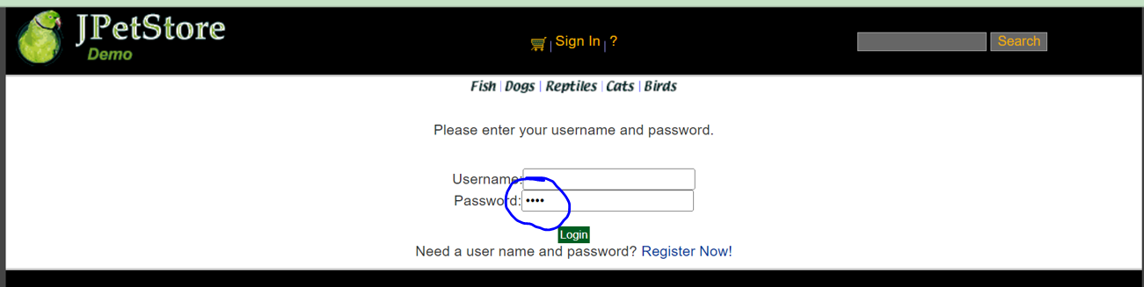

**Step to Reproduce**

* + - 1. Open url <https://petstore.octoperf.com/actions/Catalog.action> via browser
      2. Click Sign In button

**Expected Result**

When user click Sign In button ,field password must be empty

**Title:** *Password* and *Repeat Password* field not masking when user typing

**Bug ID :** QE-20230516-002

**Area Path : Signing Up Page**

**Priority : Medium**

**Severity : Medium**

**Assigned to:** Developer-Y  
**Reported By:** Yunus Bahar  
**Reported On:** 16 May 2023  
**Reason:** Defect  
**Status:** New  
**Environment:** Google Chrome

**Description :**

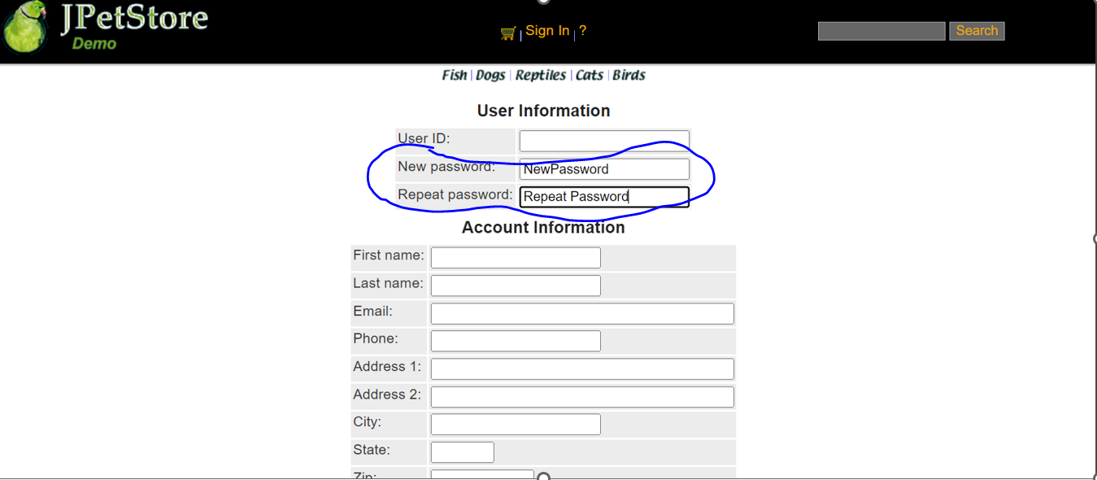

**Step to Reproduce**

* + - 1. Open url <https://petstore.octoperf.com/actions/Catalog.action> via browser
      2. Click Sign In button
      3. Click Register Now
      4. Fill in *Password* Field
      5. Fill in *Repeat Password* Field

**Expected Result**

*Password* and *New Password* Field must be masking



**Title:** Duplicate items Labrador Retriever

**Bug ID :** QE-20230516-003

**Area Path : Browsing Catalog Page**

**Priority : Medium**

**Severity : Medium**

**Assigned to:** Developer-Y  
**Reported By:** Yunus Bahar  
**Reported On:** 16 May 2023  
**Reason:** Defect  
**Status:** New  
**Environment:** Google Chrome

**Description :**

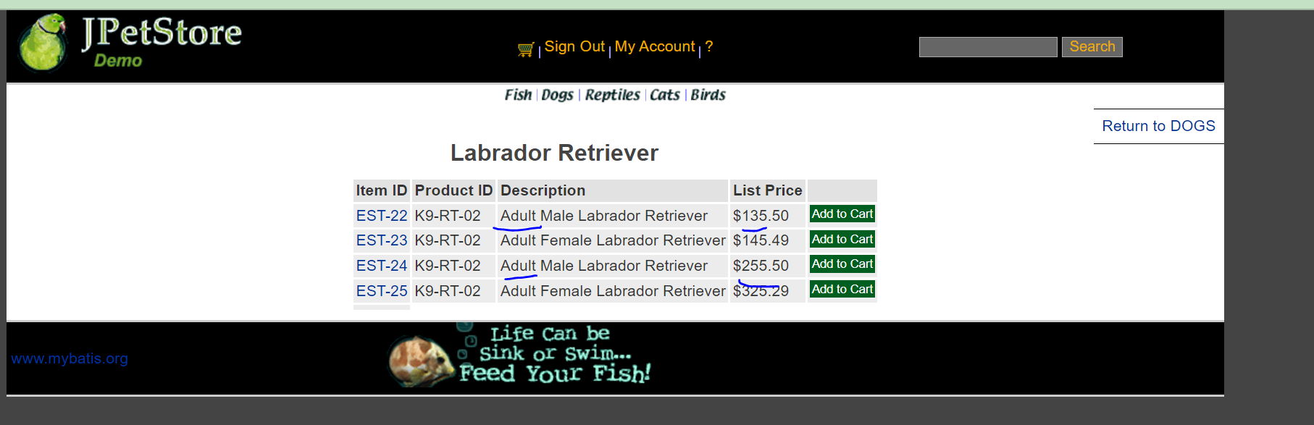

**Step to Reproduce**

* + - 1. Open url <https://petstore.octoperf.com/actions/Catalog.action> via browser
      2. Click Dogs category
      3. Click K9-RT-02

**Expected Result**

Product items cannot to be duplicate each other